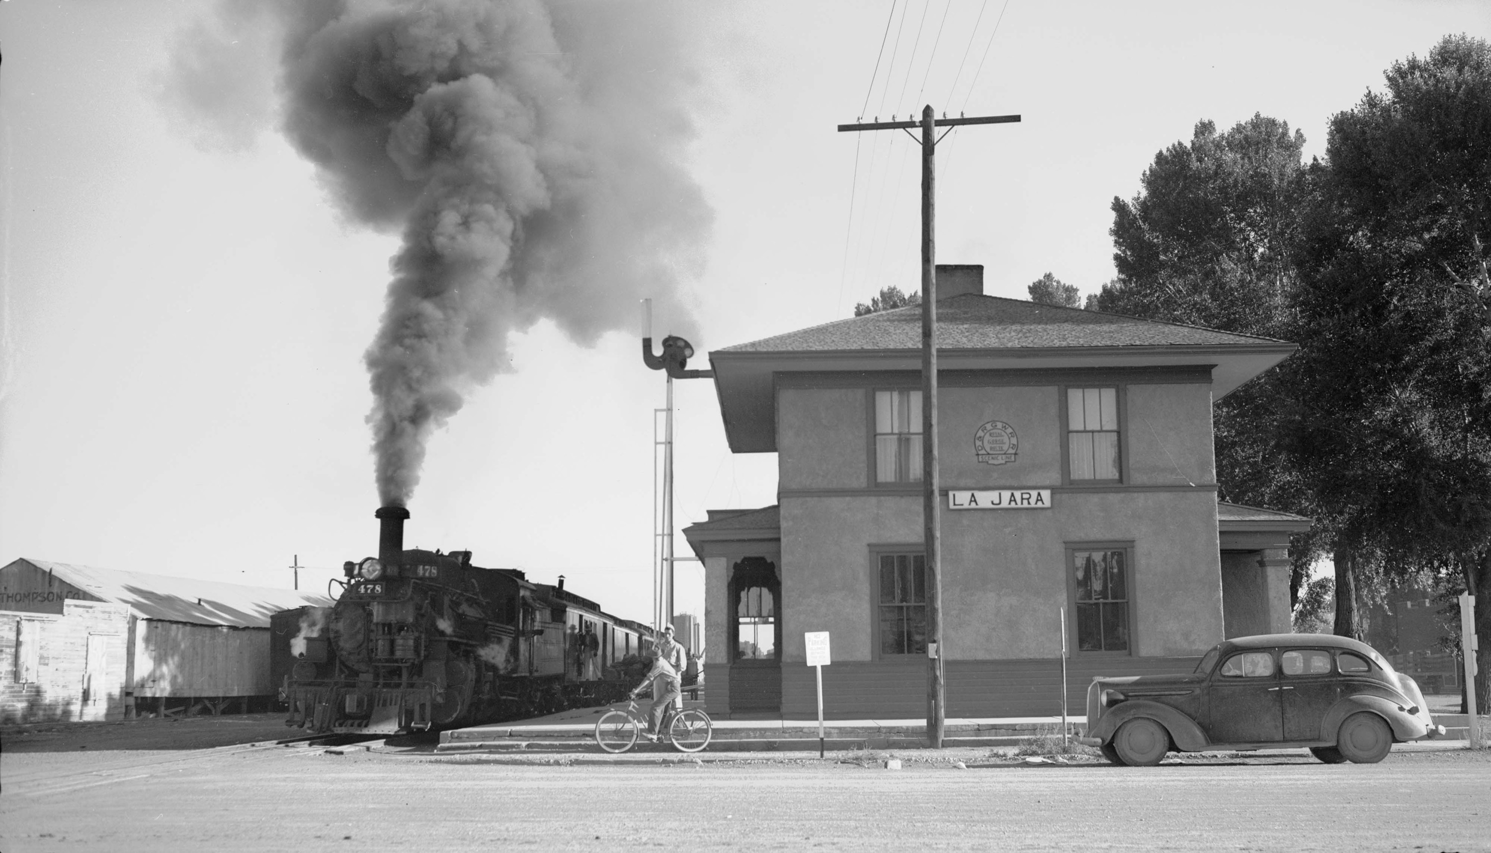
Town of La Jara
221 Broadway – PO Box 273 – La Jara, CO 81140
(719)274-5363 – Fax: (719)274-5986

Work Session

Wednesday, May 30, 2018 6:30 p.m.

Meeting location: La Jara Town Hall

221 Broadway, La Jara, Co 81140

Discussion Items:

- Weed spraying

- Personnel policy manual

- Neighborhood Watch Program

CONFERENCE ROOM
TOWN HALL
Individuals with disabilities needing auxiliary aid(s) may request assistance by contacting the clerk at the Town Hall: 274-5363. We would appreciate it if you would contact us at least 48 hours in advance of the scheduled meeting so that arrangements can be made to locate the requested auxiliary aid(s).

